ĐỀ THI TIẾNG ANH Mã đề: 02
Trình độ A2
Họ và tên thí sinh: ……………..……………………………………………………….…………………………………………………………
Số báo danh: ……………..…………………………………………...……. Phòng thi số: …………………………….……………

PAPER TWO LISTENING (Approximately 15 minutes)
PART 1: Questions 1 – 5
There are five questions in this part. For each question there are three answer choices and a short recording. Tick (√) the correct answer. You will hear the piece twice.
Example: How many people were at the meeting?
A. 3 B. 13 √ C. 30
1. How does the man travel to Liverpool?
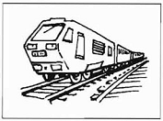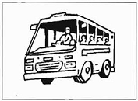
A □ B □ C □
2. Which bill has just arrived?

A □ B □ C □
3. What will they do tomorrow afternoon?
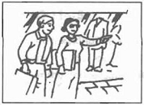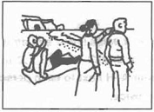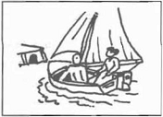
A □ B □ C □
4. How did the man hear about the fire?

A □ B □ C □
5. What time did Mr. Thompson ring?
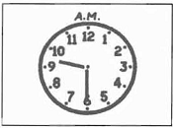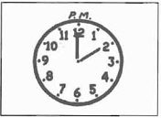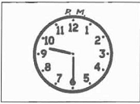
A □ B □ C □

PART 2: Questions 6-10
Listen to Rose talking to Steve about her day. What is Rose going to do at each time?
For questions 6-10, write a letter A-H next to each time. You will hear the conversation twice.

EXAMPLE | ANSWER
0 9.00 a.m. | E
TIMES |  | ACTIVITIES
6 10.00 a.m.  7 11.00 a.m.  8 12.00 a.m.  9 1.00 p.m.  10 2.00 p.m. |  | A art lesson  B have lunch  C help Steve  D meet Bill  E see doctor  F see teacher  G study  H swim

PART 3: Questions 11-15
Listen to Sarah talking to her friend Jane, about a new job.
For questions 11-15, tick (√) A, B, or C. You will hear the conversation twice.
Example: 0. Sarah’s boss wants a new
A. manager
B. shop assistant
√ C. secrectary
11. Sarah usually starts work at
A. 6.00
B. 8.30
C. 9.00
12. In a new job, Jane can earn
A. £160 a week
B. £180 a week
C. £210 a week
13. Sarah has lunch
A. in a cafe
B. in a park
C. at home
14. In the new job, Jane can have
A. 3 weeks’holiday
B. 4 weeks’holiday
C. 5 weeks’holiday
15. The manager’s name is Mr
A. Fawset
B. Fawcett
C. Fausett

